33. Transaction Handling in JDBC

TransactionDemo.java

import java.sql.*;

public class TransactionDemo {

public static void main(String[] args) {

try {

Class.forName("com.mysql.cj.jdbc.Driver");

Connection con = DriverManager.getConnection(
"jdbc:mysql://localhost:3306/corejava",
"root",
"123456");

// Start Transaction
con.setAutoCommit(false);

int fromAcc = 1001;
int toAcc = 1002;
double amount = 1000;

// Debit Query
PreparedStatement debit = con.prepareStatement(
"UPDATE accounts SET balance = balance - ? WHERE acc_no = ?");

debit.setDouble(1, amount);
debit.setInt(2, fromAcc);

int d = debit.executeUpdate();

// Credit Query
PreparedStatement credit = con.prepareStatement(
"UPDATE accounts SET balance = balance + ? WHERE acc_no = ?");

credit.setDouble(1, amount);
credit.setInt(2, toAcc);

int c = credit.executeUpdate();

if (d > 0 && c > 0) {
con.commit();
System.out.println("Transaction Successful");
} else {
con.rollback();
System.out.println("Transaction Failed");
}

con.close();

} catch (Exception e) {
e.printStackTrace();
}
}
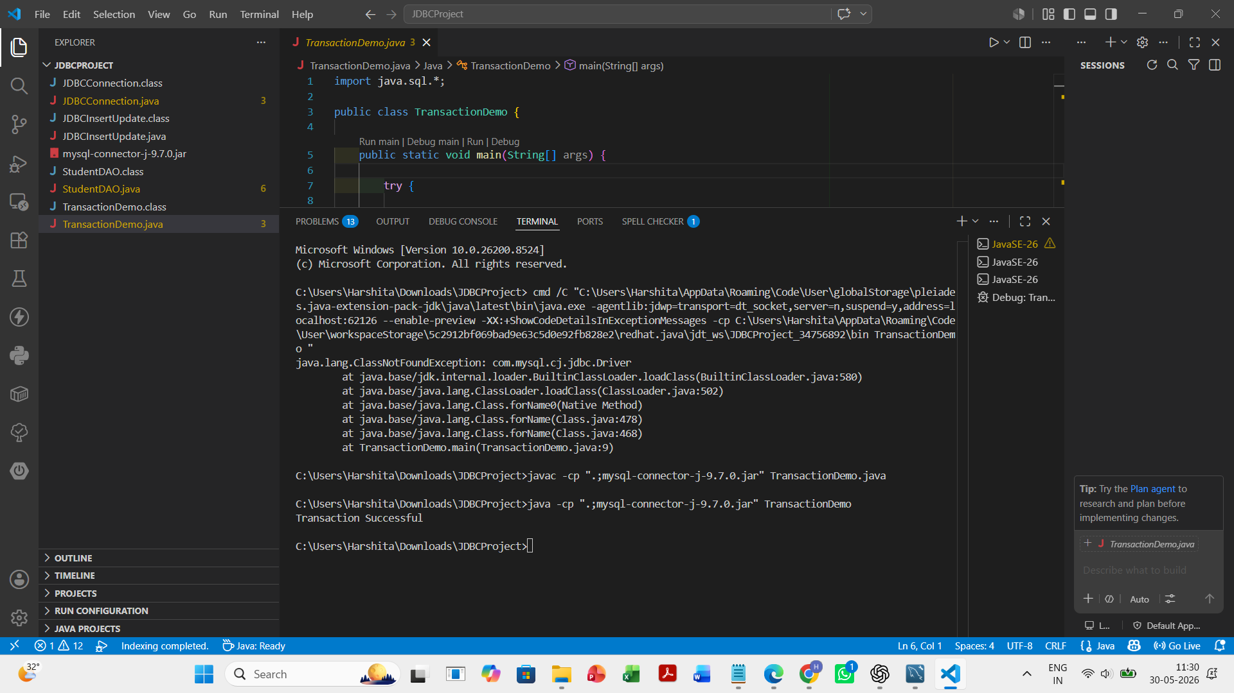
}

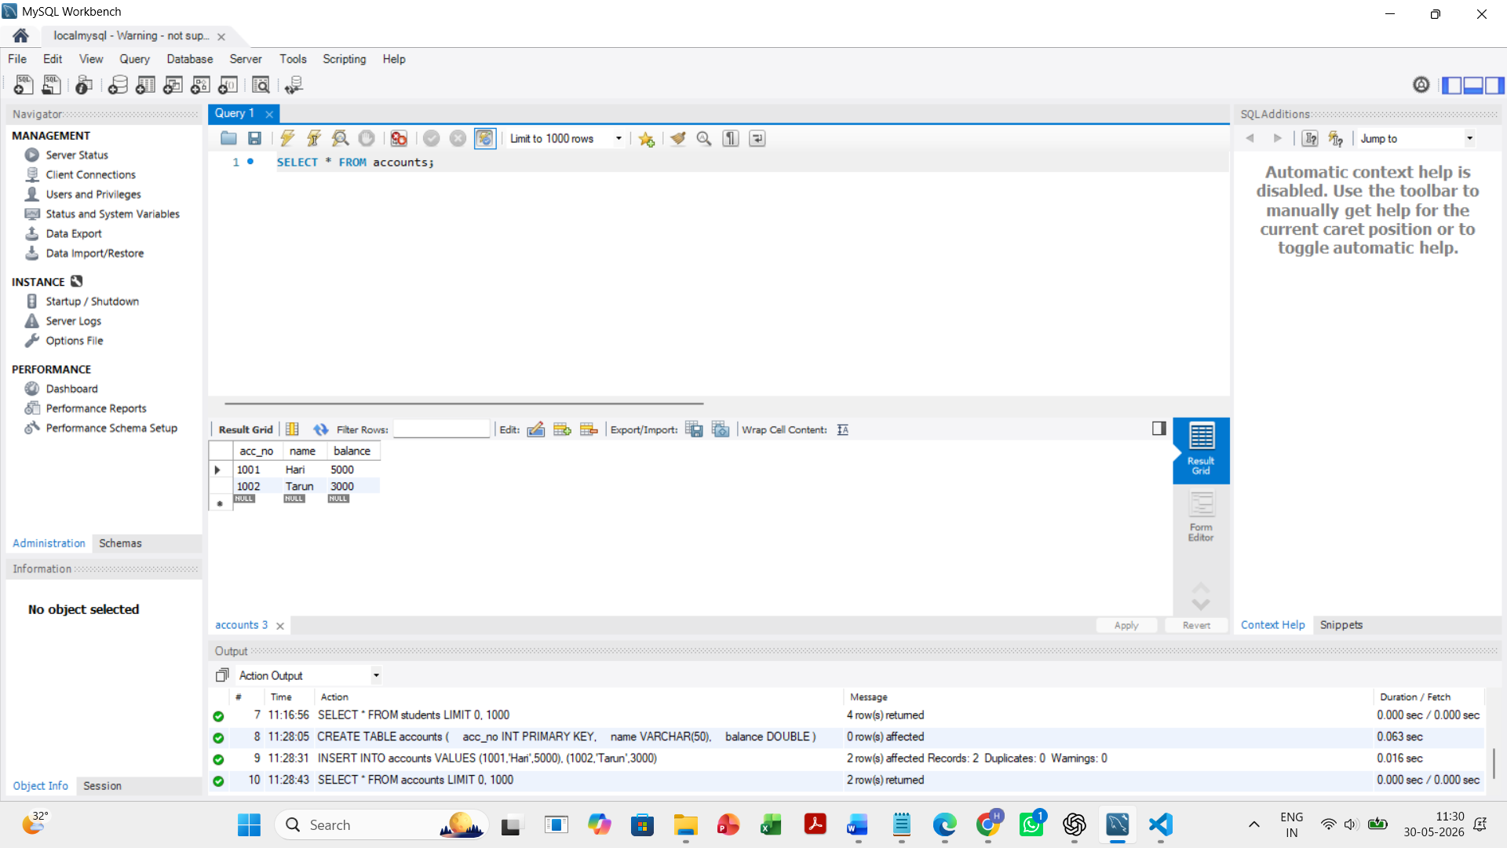
Before update:

After update:
